***Report of SAP***

1. Topic :

ANIMAL ABUSE

1. Objectives :
2. Shelter an animal in need..
3. Don’t just concern yourself with basic needs – give your pet positive experiences that really enhance its well-being.
4. Be an example of kindness to other pets.
5. Do what you can to stop someone from mistreating an animal. However, be sensible and don’t put yourself in danger.
6. If necessary, seek help from other witnesses.
7. Report animal cruelty, abuse or neglect.
8. Teach your children to have respect for animals.
9. Educate people around you about the issue.
10. Know about and fulfil the needs of your pet.
11. Work done: We had online group discussion with our team mates on animal abuse. We created instagram account and uploaded material regarding the same. We wrote blogs on animal abuse and make sure that it reaches maximum number of people.
12. Screenshots :

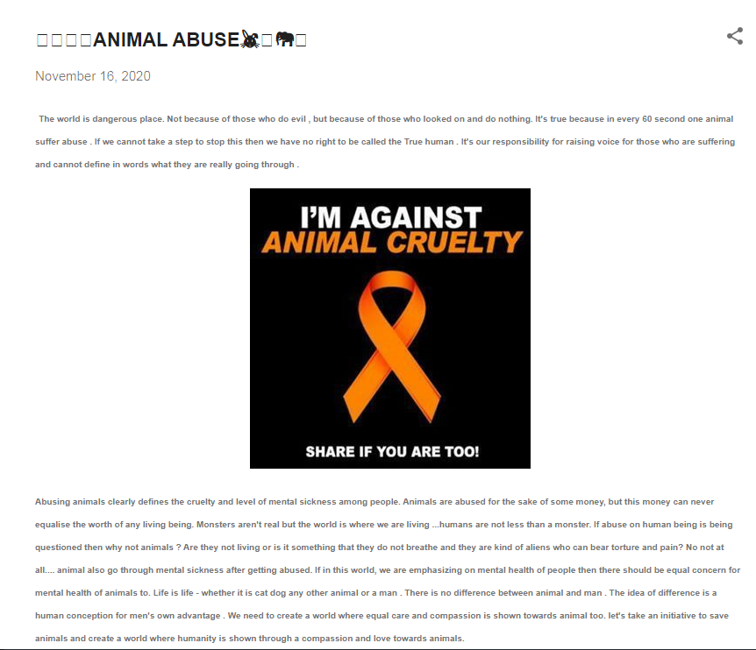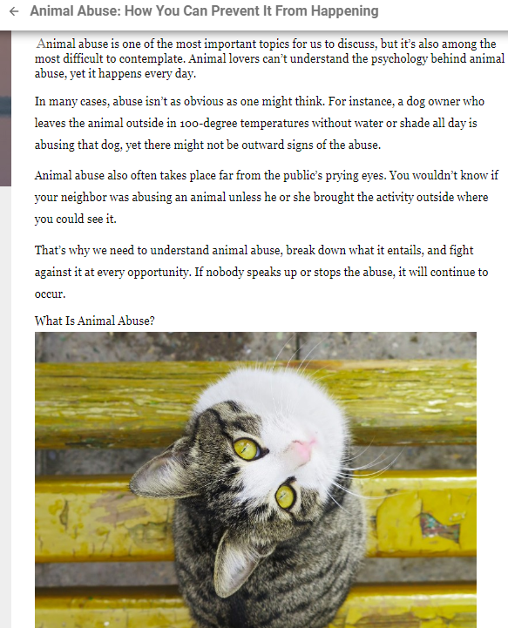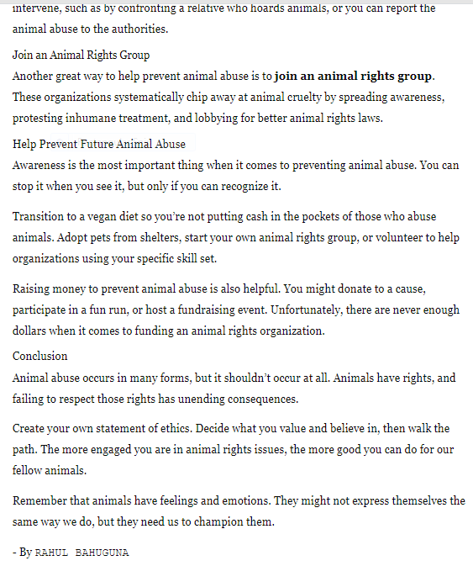

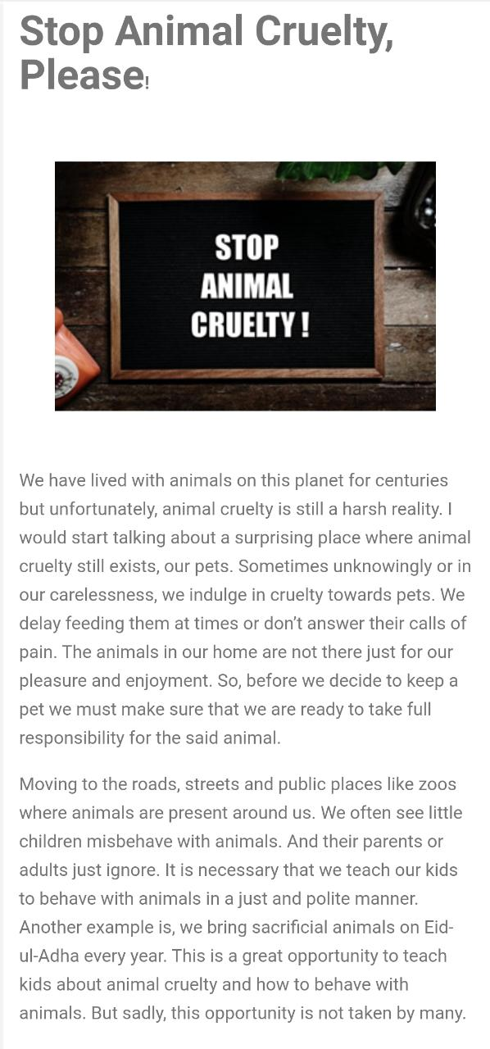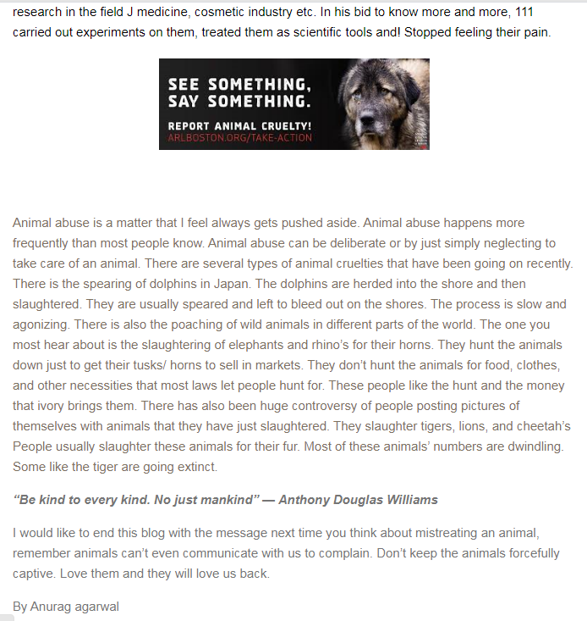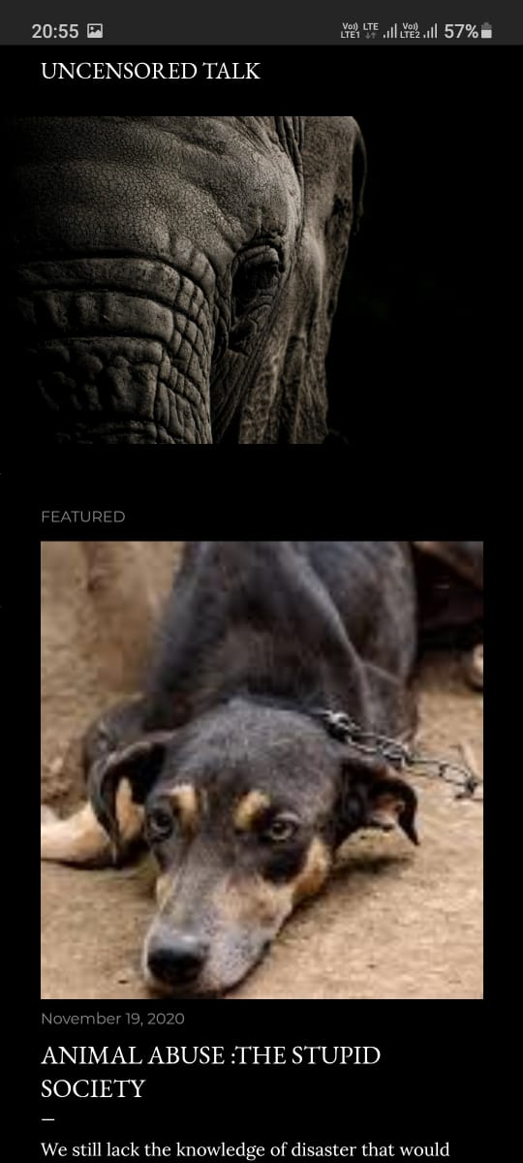

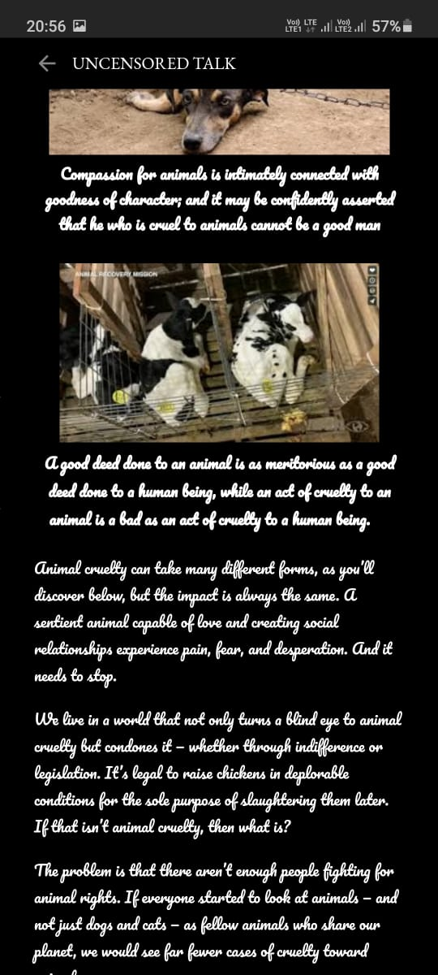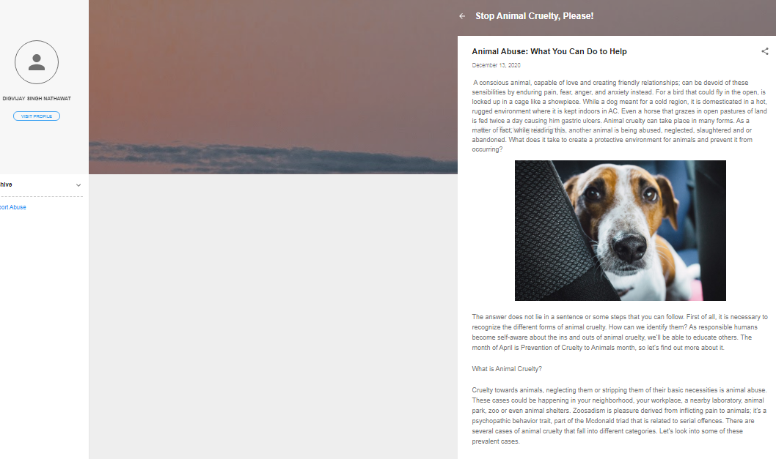

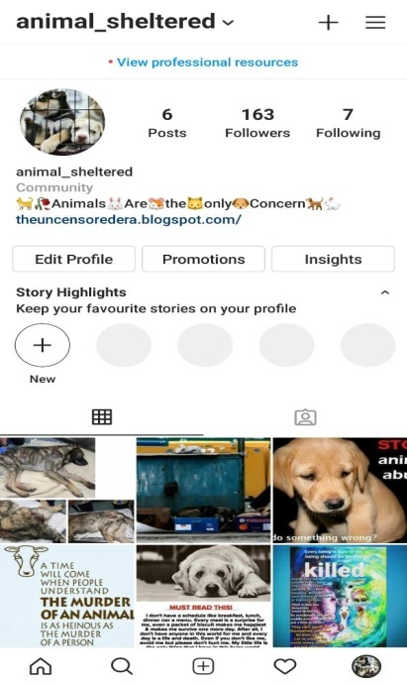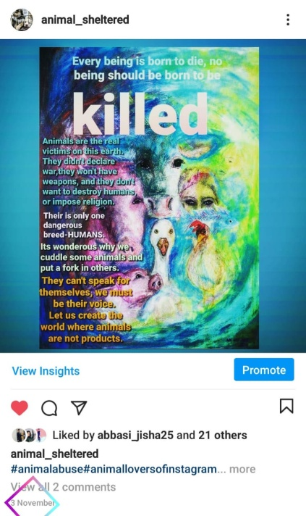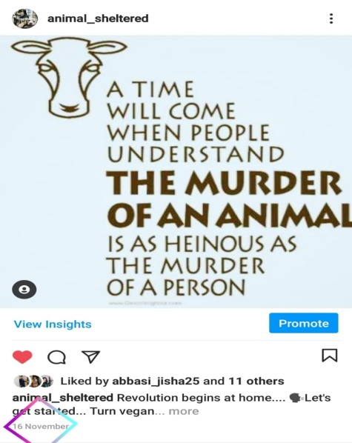

1. Hyperlinks to the media profiles

* BLOGS

1. <https://reservetherights.blogspot.com/2020/11/animal-abuse.html>–AAKRITI GOYAL
2. <https://animalabuse11.blogspot.com/2020/12/animal-abuse-how-you-can-prevent-it.html>–RAHUL BAHUGUNA
3. <https://theuncensoredera.blogspot.com/?m=1> –ARPIT AGARWAL
4. <https://reservetherightsalways.blogspot.com/2020/11/animal-abuse.html> –ANURAG AGARWAL
5. <https://stopanimalcrueltyplease1.blogspot.com/2020/12/animal-abuse-what-you-can-do-to-help.html> -DIGVIJAY SINGH NATHAWAT

* INSTAGRAM

1. <https://www.instagram.com/p/CHH_ZZjjq--/?igshid=elf78kac085k>
2. <https://www.instagram.com/p/CHcwZcUDbOT/?igshid=spvi225ftp1a>
3. <https://www.instagram.com/p/CHpo9wuDAi2/?igshid=sfs6mfr72aym>
4. <https://www.instagram.com/p/CHsqje3DcUB/?igshid=1sfn1lpmdhej1>
5. <https://www.instagram.com/p/CIvhiGFDQf3/?igshid=1qlgbcx448qti>
6. <https://www.instagram.com/p/CIvh9ZrjHfO/?igshid=cj3yeuf3behv>
7. <https://www.instagram.com/p/CIvsn5DDgAr/?igshid=7ovhi7viujlz>
8. Learning outcomes
9. Offer help to people who are overwhelmed with their animal.
10. Animals aren’t necessarily neglected out of a lack of love.
11. An owner may not have the psychological resources to provide an animal with the appropriate care. Whatever the reasons may be, an affected pet must be removed from a place of neglect and given the care it needs to live and thrive. Any help you give to an animal may help a human too.
12. We helped people to understand that they can intervene in situations where animals are being neglected or even tormented. Animals have a right to live without fear or pain, and we have a responsibility to step in if their rights aren’t respected.
13. If you witness any form of animal cruelty, report it to the police or other authorities. Act immediately to prevent further cruelty.
14. Set a good example by being respectful towards animals. Show children how to treat animals with love and consideration. Help them to grow up to become the next generation of advocates for animals.
15. TEAM MEMBERS

* AAKRITI GOYAL
* ARPIT AGARWAL
* ANURAG AGARWAL
* DIGVIJAY SINGH NATHAWAT
* RAHUL BAHUGUNA